**DAILY ONLINE ACTIVITIES SUMMARY**

|  |  |  |  |  |  |  |  |  |
| --- | --- | --- | --- | --- | --- | --- | --- | --- |
| **Date:** | **6-7-2020** | | | | | **Name:** | **Prajna** | |
| **Sem & Sec** | **8th sem ‘B’** | | | | | **USN:** | **4AL16CS067** | |
| **Online Test Summary** | | | | | | | | |
| **Subject** | | **-** | | | | | | |
| **Max. Marks** | | **-** | | **Score** | | | **-** | |
| **Certification Course Summary** | | | | | | | | |
| **Course** | **Introduction to CSS** | | | | | | | |
| **Certificate Provider** | | | **Great learning** | | **Duration** | | | **5hrs** |
| **Coding Challenges** | | | | | | | | |
| **Problem Statement:**1**.** Write a c program to find total number of duplicate elements in array. | | | | | | | | |
| **Status: Completed** | | | | | | | | |
| **Uploaded the report in GitHub**  **GitHub link:** | | | | | **Yes**  **https://github.com/alvas-education-foundation/prajna_k** | | | |
| **If yes Repository name** | | | | | **prajna_k** | | | |
| **Uploaded the report in slack** | | | | | **yes** | | | |

Online Test Details: (Attach the snapshot and briefly write the report for the same)

Certification Course Details: (Attach the snapshot and briefly write the report for the same)

Coding Challenges Details: (Attach the snapshot and briefly write the report for the same)

2) certification course

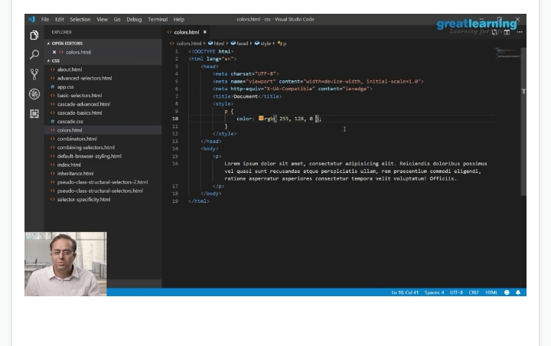

3) coding challenges

#include <stdio.h>

void main()

{

int arr1[100];

int arr2[100];

int arr3[100];

int n,mm=1,ctr=0;

int i, j;

printf("\n\nCount total number of duplicate elements in an array:\n");

printf("---------------------------------------------------------\n");

printf("Input the number of elements to be stored in the array :");

scanf("%d",&n);

printf("Input %d elements in the array :\n",n);

for(i=0;i<n;i++)

{

printf("element - %d : ",i);

scanf("%d",&arr1[i]);

}

/*----------------- copy in other array ------------------------------------*/

for(i=0;i<n; i++)

{

arr2[i]=arr1[i];

arr3[i]=0;

}

/*------------------- mark the elements are duplicate -------------------------*/

for(i=0;i<n; i++)

{

for(j=0;j<n;j++)

{

if(arr1[i]==arr2[j])

{

arr3[j]=mm;

mm++;

}

}

mm=1;

}

/*--------------- Prints the array ------------------------------------*/

for(i=0; i<n; i++)

{

if(arr3[i]==2){ctr++;}

}

printf("The total number of duplicate elements found in the array is: %d \n", ctr);

printf("\n\n");

}

|  |
| --- |
|  |
|  |  |
|  |  |
|  |  |
|  |  |
|  |  |